INTS Code Migration 0956

# Prerequisites

The following logins are required

* SPM administrator login
* APM administrator login
* WebIDE login
* Database login
* Database host and port

A public and private key pair need to be generated and the public key added to the CDL drop box. The private key needs to be added to APM.

# SAP_Admin User

Create SAP_Admin user in Commissions with Administrator role

Add internal user SAP_Admin in portal and assign roles:

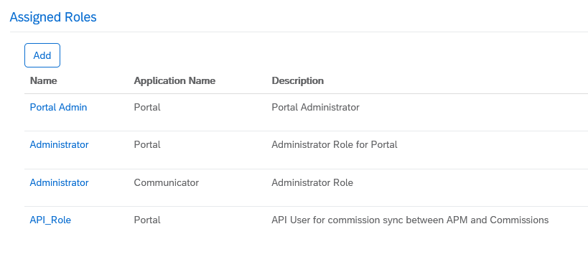

# Support Tickets

Use following:

|  |  |
| --- | --- |
| Customer ID | 0000203178 |
| S-User | S0022915347 (Jochen Gärtner) |

<https://launchpad.support.sap.com/#/incident/create>

# ODATA

## Support Ticket

24678 / 2021

|  |  |
| --- | --- |
| Subject | Enable ODATA adaptor for tenant 0956 |
| Description | Please enable ODATA adaptor for tenant 0956.  Jon Cadby is primary contact for this case. |

## Remote Source

Right-click Remote Sources 🡪 Add Remote Source

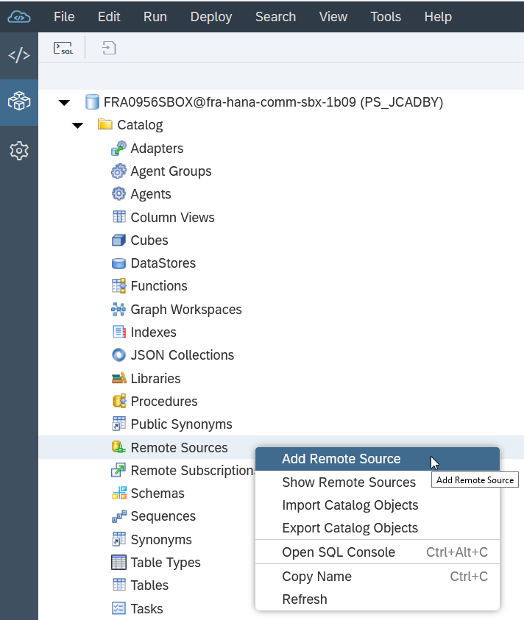

Enter the settings

| **Property** | **Value** |
| --- | --- |
| Source Name | COMN_OData |
| Adapter Name | OData Adapter |
| Source Location | dpserver |
| URL | https://0956.callidusondemand.com:443/TrueComp-SaaS/CommissionsService.svc |
| Support Format Query | true |
| Credentials Mode | Technical User |
| User | SAP_Admin |
| Pwd | Use portal password for user |

## Virtual Table

Create the virtual table:

|  |
| --- |
| create virtual table EXT.VT_PipelineRuns AT "COMN_OData"."<NULL>"."<NULL>"."PipelineRuns"; |

# EXT Database Objects

Support Ticket

155557 / 2021

|  |  |
| --- | --- |
| Subject | 0955 - CS_Credit Update Privileges |
| Description | Please grant update privileges on all GenericAttribute, GenericNumber, UnitTypeForGenericNumber, GenericDate, and GenericBoolean fields. |

SIT ticket # 335840 / 2021

## Event Framework

### Objects

Create the objects in the following order:

| **Order** | **Object Type** | **Object Name** |
| --- | --- | --- |
| 1 | FUNCTION | COMN_FNC_GET_FIELD |
| 1 | FUNCTION | COMN_FNC_GET_PAYMENT_DATE |
| 1 | LIBRARY | COMN_LIB_CONSTANTS |
| 1 | TABLE | COMN_BZO |
| 1 | TABLE | COMN_BZO_LANDING |
| 1 | TABLE | COMN_BZO_PRELANDING |
| 1 | TABLE | COMN_CODE_VALUE |
| 1 | TABLE | COMN_CONFIG_EVENT_OWNERSHIP |
| 1 | TABLE | COMN_DEBUG |
| 1 | TABLE | COMN_ERROR |
| 1 | TABLE | COMN_EVENT |
| 1 | TABLE | COMN_EVENT_BAUSTEIN_TRACE |
| 1 | TABLE | COMN_EVENT_BREAK |
| 1 | TABLE | COMN_EVENT_BREAK_TEMP |
| 1 | TABLE | COMN_EVENT_BREAK_TRACE |
| 1 | TABLE | COMN_EVENT_BREAK_TRACE_TEMP |
| 1 | TABLE | COMN_EVENT_BZO |
| 1 | TABLE | COMN_EVENT_LANDING |
| 1 | TABLE | COMN_EVENT_ORDER_ID |
| 1 | TABLE | COMN_EVENT_PRELANDING |
| 1 | TABLE | COMN_EVENT_TRACK |
| 1 | TABLE | COMN_EVENT_TRACK_TEMP |
| 1 | TABLE | COMN_EVENT_TRACK_TRACE |
| 1 | TABLE | COMN_EVENT_TRACK_TRACE_TEMP |
| 1 | TABLE | COMN_FILE |
| 1 | TABLE | COMN_FILE_TRACE |
| 1 | TABLE | COMN_FILE_TYPE |
| 1 | TABLE | COMN_FILE_VALIDATION |
| 1 | TABLE | COMN_FILE_VALIDATION_SQL |
| 1 | TABLE | COMN_GASTAGESALESORDER |
| 1 | TABLE | COMN_GASTAGESALESTRANSACTION |
| 1 | TABLE | COMN_INVALID_OBJECTS |
| 1 | TABLE | COMN_LIABILITY |
| 1 | TABLE | COMN_LIABILITY_TEMP |
| 1 | TABLE | COMN_LOCK |
| 1 | TABLE | COMN_POLICY_PROCESS_STATUS |
| 1 | TABLE | COMN_RAT_AP_CREDIT_TEMP |
| 1 | TABLE | COMN_RAT_AP_INT_TEMP |
| 1 | TABLE | COMN_RAT_AP_TEMP |
| 1 | TABLE | COMN_STAGEHOOK_REF |
| 1 | TABLE | COMN_STAGESALESORDER |
| 1 | TABLE | COMN_STAGESALESTRANSACTION |
| 1 | TABLE | COMN_STAGETRANSACTIONASSIGN |
| 1 | TABLE | COMN_TRANSACTION |
| 1 | TABLE | COMN_TRANSACTION_BP_TEMP |
| 1 | TABLE | COMN_VALIDATION_CODE |
| 1 | TABLE | COMN_VBO |
| 1 | TABLE | COMN_VBO_LANDING |
| 1 | TABLE | COMN_VBO_PRELANDING |
| 1 | TABLE | COMN_WF_ERROR_HANDLING |
| 1 | TABLE | COMN_WF_ERROR_HANDLING_ASSIGNMENT |
| 1 | TABLE | COMN_WF_ERROR_HANDLING_GROUP_CONFIG |
| 1 | TABLE | GTMP_COMN_PARTICIPANT_CHECK_HIERARCHY |
| 1 | TABLE | GTMP_COMN_PARTICIPANT_CHECK_REQUEST |
| 1 | TABLE | GTMP_COMN_PARTICIPANT_CHECK_RESULT |
| 1 | TABLE | PL_BATCH_FILTER |
| 1 | TABLE | PL_BATCH_LOG |
| 1 | TABLE | PL_CONFIG |
| 1 | TABLE | PL_DEBUG |
| 1 | TABLE | PL_LEDGER_DELTA |
| 1 | TABLE | PL_LEDGER_LOG |
| 1 | TABLE | PL_LEDGER_SUMMARY |
| 1 | TABLE | PL_LEDGER_SUMMARY_LOG |
| 1 | TABLE | PL_PAYEE |
| 1 | TABLE | PL_PERIOD |
| 1 | TABLE | PL_SNAPSHOT_CREDIT |
| 1 | TABLE | PL_SNAPSHOT_CREDIT_TEMP |
| 1 | TABLE | PL_SNAPSHOT_DEPOSIT |
| 1 | TABLE | PL_SNAPSHOT_DEPOSIT_TEMP |
| 1 | TABLE | PL_SNAPSHOT_INCENTIVE |
| 1 | TABLE | PL_SNAPSHOT_INCENTIVE_TEMP |
| 1 | TABLE | PL_SNAPSHOT_MEASUREMENT |
| 1 | TABLE | PL_SNAPSHOT_MEASUREMENT_TEMP |
| 1 | TABLE | PL_SQL_LOG |
| 1 | VIEW | COMN_V_INVALID_OBJECTS |
| 1 | VIEW | VIEW_COMN_VALID_BA |
| 1 | VIEW | VIEW_COMN_VALID_CANCELLATION_TYPE |
| 1 | VIEW | VIEW_COMN_VALID_GEVO |
| 1 | VIEW | VIEW_COMN_VALID_KG |
| 1 | VIEW | VIEW_COMN_VALID_LVB_ID |
| 1 | VIEW | VIEW_COMN_VALID_PRODUCTTYPE |
| 1 | VIEW | VIEW_COMN_VALID_TKZ |
| 1 | VIEW | VIEW_COMN_VALID_VERTRAGSARTID |
| 1 | VIEW | VIEW_COMN_VALID_VZKZ |
| 2 | FUNCTION | COMN_FNC_GET_EVENT_TYPE |
| 2 | FUNCTION | COMN_FNC_GET_FILE_TIMESTAMP |
| 2 | LIBRARY | COMN_LIB_CHECKS_1_PARTICIPANT_VALIDATION |
| 2 | LIBRARY | COMN_LIB_PARTICIPANT_HIERARCHY |
| 2 | PROCEDURE | COMN_PRC_DEBUG |
| 2 | PROCEDURE | COMN_PRC_DEBUG_ERROR |
| 2 | SEQUENCE | COMN_SEQ_BZO_KEY |
| 2 | SEQUENCE | COMN_SEQ_TRACK_KEY |
| 2 | SEQUENCE | COMN_SEQ_VBO_KEY |
| 2 | VIEW | COMN_V_EVENT_FILE |
| 2 | VIEW | COMN_V_WF |
| 2 | VIEW | PL_V_BATCH |
| 2 | VIEW | PL_V_BATCH_DETAIL |
| 2 | VIEW | PL_V_BATCH_LEDGER |
| 2 | VIEW | PL_V_BATCH_SUMMARY |
| 3 | LIBRARY | COMN_LIB_CHECKS_1_HIERARCHY_VALIDATION |
| 3 | LIBRARY | COMN_LIB_CHECKS_2_PARTICIPANT_VALIDATION |
| 3 | LIBRARY | COMN_LIB_PIPELINE |
| 3 | LIBRARY | COMN_LIB_STAGEHOOK |
| 3 | LIBRARY | COMN_LIB_VALIDATION_UTILS |
| 4 | FUNCTION | COMN_FNC_ISBOOLEAN |
| 4 | FUNCTION | COMN_FNC_ISDATE |
| 4 | FUNCTION | COMN_FNC_ISNUMBER |
| 4 | FUNCTION | COMN_FNC_ISTIMESTAMP |
| 4 | FUNCTION | COMN_FNC_NOTNULL |
| 4 | FUNCTION | COMN_FNC_TOBOOLEAN |
| 4 | FUNCTION | COMN_FNC_TODATE |
| 4 | FUNCTION | COMN_FNC_TONUMBER |
| 4 | FUNCTION | COMN_FNC_TOTIMESTAMP |
| 4 | LIBRARY | COMN_LIB_BZO |
| 4 | LIBRARY | COMN_LIB_EVENT_VALIDATION |
| 4 | LIBRARY | COMN_LIB_NVG_EVENT_VALIDATION |
| 4 | LIBRARY | COMN_LIB_PARTICIPANT_VALIDATION |
| 4 | LIBRARY | COMN_LIB_UTILS |
| 4 | LIBRARY | COMN_LIB_VBO |
| 4 | PROCEDURE | COMN_PRC_STAGEHOOK |
| 5 | FUNCTION | COMN_FNC_ADD_DAYS |
| 5 | FUNCTION | COMN_FNC_DAYS_BETWEEN |
| 5 | LIBRARY | COMN_LIB_EVENT_TRANSACTION |
| 5 | LIBRARY | COMN_LIB_WORKFLOW |
| 5 | PROCEDURE | COMN_PRC_BZO |
| 5 | PROCEDURE | COMN_PRC_VBO |
| 6 | LIBRARY | COMN_LIB_DATABASE |
| 6 | LIBRARY | COMN_LIB_EVENT_TRACK |
| 6 | LIBRARY | COMN_LIB_LIABILITY |
| 6 | LIBRARY | COMN_LIB_RAT_AP |
| 7 | LIBRARY | COMN_LIB_EVENT |
| 7 | LIBRARY | PL_LIB |
| 8 | FUNCTION | PL_FNC_GET_RESULT_KEY |
| 8 | FUNCTION | PL_FNC_GET_RESULT_KEY_CREDIT |
| 8 | FUNCTION | PL_FNC_GET_RESULT_KEY_DEPOSIT |
| 8 | LIBRARY | COMN_LIB_SCHEDULE |
| 8 | PROCEDURE | COMN_PRC_EVENT |

### Config Data

Move config data from 0955 to 0956

* Right click 0955 database 🡪 Export Catalog Objects
  + Export Location: Local Computer
  + Local archive: 0955_Config_YYYYMMDD
  + Click Add Catalog Objects and then add each of the following tables
    - COMN_Code_Value
    - COMN_File_Type
    - COMN_File_Validation
    - COMN_Stagehook_Ref
    - COMN_Validation_Code
    - COMN_WF_Error_Handling_Group_Config
  + Click Export and save the resulting file
* In 0956, drop each of the tables that were exported
* Right-click 0956 database 🡪 Import Catalog Objects
  + Import objects from: Local Computer
  + Local archive: filename from previous step
  + Click Import
* Refresh the dynamic SQL in 0956:

|  |
| --- |
| call ext.comn_lib_validation_utils:data_type_sql('GEVO'); |

# CDL Config - DONE

Global Settings 🡪 Autorun = Yes

File Types

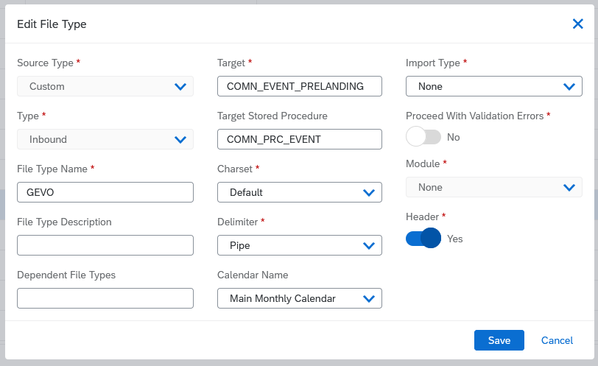

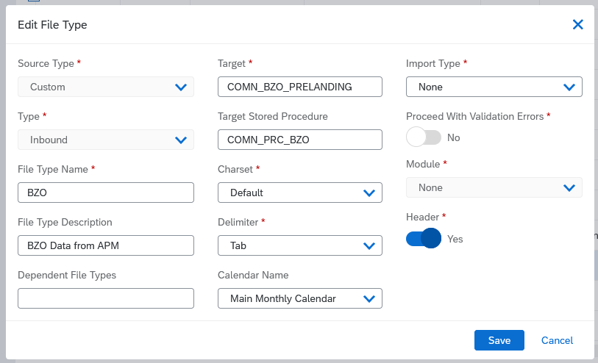

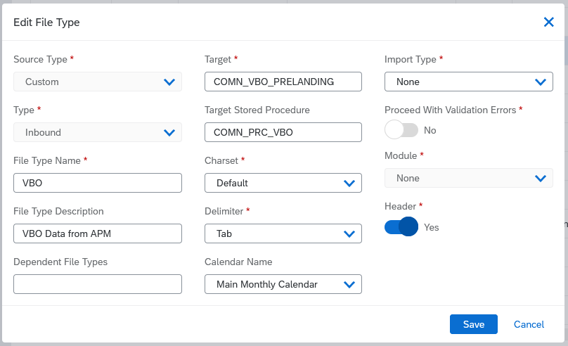

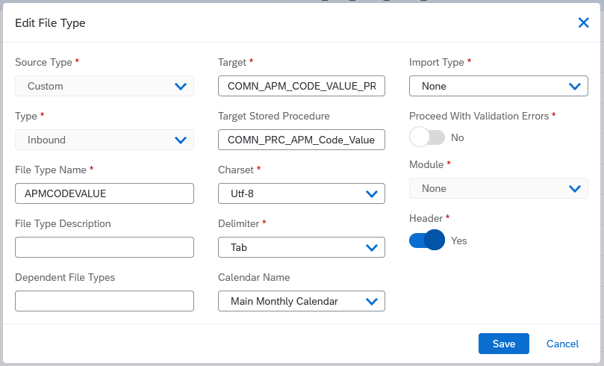

# APM

## FTP

Administration 🡪 Processing Configuration 🡪 FTP Server Search

Update ftp settings for 0956

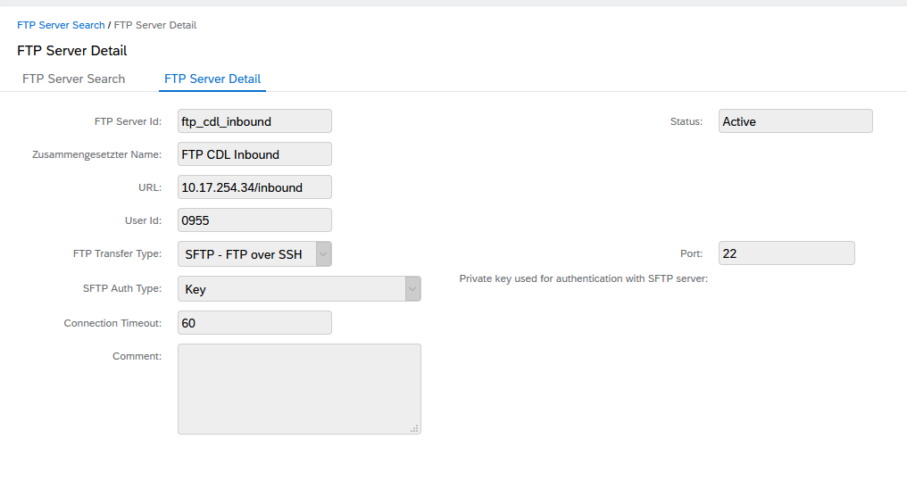

## QBQueries

Integration 🡪 Configuration 🡪 QBQuery Search

* qbq_bzo_to_ext
* qbq_vbo_to_ext
* qbq_apmcodevalue_to_ext

## Extracts

Integration 🡪 Configuration 🡪 Extracts Search

Extracts – change the filenames and ensure they are using the ftp “FTP CDL Inbound”

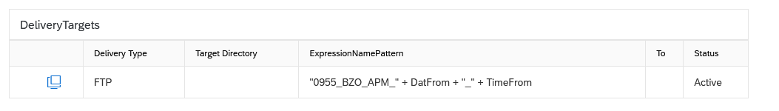

ext_bzo_to_ext

"0956_BZO_APM_" + DatFrom + "_" + TimeFrom

ext_vbo_to_ext

"0956_VBO_APM_" + DatFrom + "_" + TimeFrom

ext_ apmcodevalue _to_ext

"0956_APMCODEVALUE_APM_" + DatFrom + "_" + TimeFrom

## Scheduled Processes

Integration 🡪 Processing 🡪 Scheduled Processes

schd_bzo_to_ext – 5 mins

schd_vbo_to_ext – 5 mins

schd_apmcodevalue_to_ext – at midnight

# WebIDE

## Support Ticket: Job Scheduler

54348 / 2021

|  |  |
| --- | --- |
| Subject | Please create jobScheduler service for 0956 HANA |
| Description | Please create jobScheduler service for 0956 HANA. Jon Cadby is primary contact for this ticket. |

## Project

Create MTA project called COMN_0956

Right-click COMN_0956 🡪 Project 🡪 Project Settings 🡪 Space 🡪 Install Builder

## Node.js

Create Node.js module called COMN_nodejs with “Enable XSJS support”

Edit the package.json file to change the node version:

|  |
| --- |
| {  "dependencies": {  "@sap/xsenv": "^2.0.0",  "@sap/xsjs": "^5.2.0"  },  "description": "my description",  "devDependencies": {  "@sap/xsjs-test": "^3.0.2"  },  "files": [],  "main": "server.js",  "name": "COMN_nodejs",  "scripts": {  "start": "node server.js",  "test": "node testrun.js"  },  "engines": {  "node": "8.x"  },  "version": "1.0.0"  } |

Build COMN_node.js – the builder needs to have completed installation from earlier step.

Right-click COMN_nodejs 🡪 Run 🡪 Run as Node.js Application

This will fail:

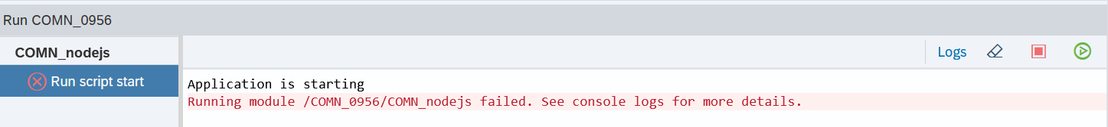

Click on Logs link and a new browser tab will open to display a URL:

|  |
| --- |
| vgz4sfxtwm9os1uy-0956-comn-nodejs.1b09.calliduscloud.com |

This URL needs to be used in a support ticket.

## Support Ticket

We must contact support to have this URL activated and also to have the scheduler

40600 / 2021

|  |  |
| --- | --- |
| Subject | 0956 Enable Node JS URL |
| Description | Please activate Node JS URL below for 0956:  vgz4sfxtwm9os1uy-0956-comn-nodejs.1b09.calliduscloud.com  Jon Cadby is primary contact for this ticket. |

## Database Module

Create SAP HANA Database Module COMN_DB

Clear Namespace

Set Schema Name to COMN_0956_EXT

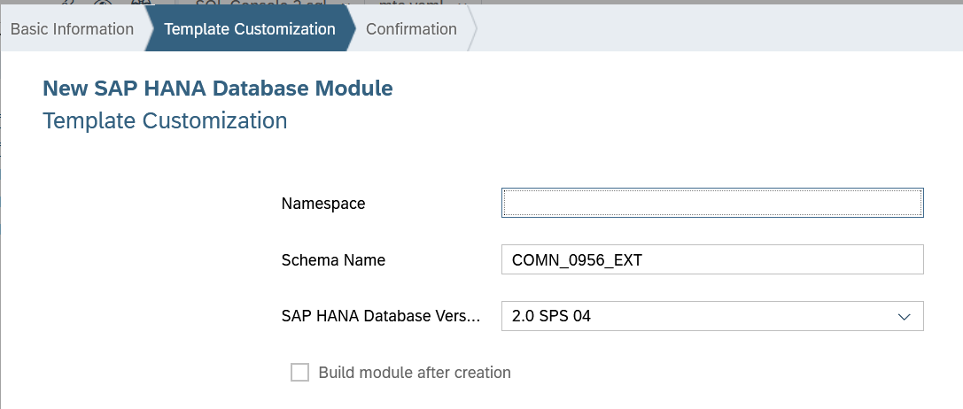

### EXT Connection

Right-click COMN_DB 🡪 New 🡪 SAP HANA Service Connection

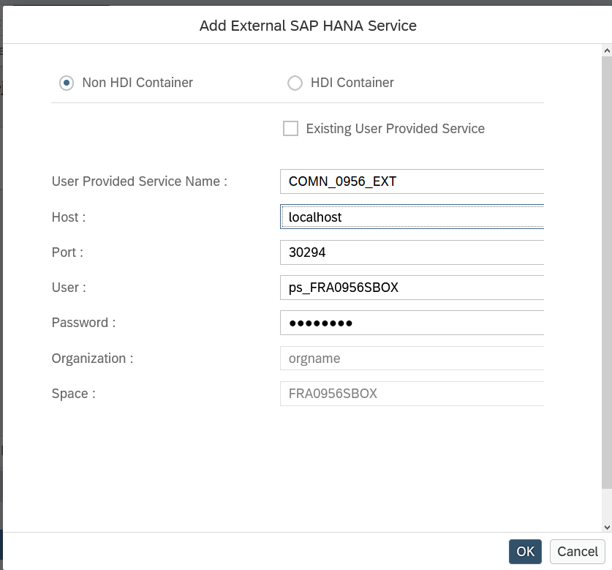

Double click mta.yaml 🡪 Modules 🡪 COMN_DB 🡪 cross-container-service-1 (resource)

Change ServiceName_1 to ServiceName_COMN_0956_EXT

Save

### Grants

Right-click COMN_DB 🡪 New 🡪 Folder

Name it cfg

Create EXT.hdbgrants file in cfg:

|  |
| --- |
| {  "ServiceName_COMN_0956_EXT": {  "object_owner": {  "schema_privileges" : [  {  "schema": "EXT",  "privileges" : [ "INSERT", "UPDATE", "SELECT", "DELETE", "EXECUTE" ],  "privileges_with_grant_option" : [ "INSERT", "UPDATE", "SELECT", "DELETE", "EXECUTE" ]  }  ]  },  "application_user": {  "schema_privileges" : [  {  "schema": "EXT",  "privileges" : [ "INSERT", "UPDATE", "SELECT", "DELETE", "EXECUTE" ],  "privileges_with_grant_option" : [ "INSERT", "UPDATE", "SELECT", "DELETE", "EXECUTE" ]  }  ]  }  }  } |

### Build

Right-click COMN_DB 🡪 Build 🡪 Build

### Synonyms

**This section is redundant – we can reference objects in the EXT schema via the grants.**

Right-click COMN_DB/src 🡪 New 🡪 Database Artifact

File Name: EXT

File Type: . dbsynonym

Create synonym for COMN_PRC_EVENT

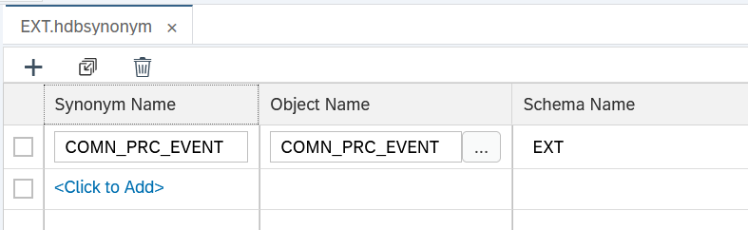

Build db module again

## Job Scheduler

Double click mta.yaml 🡪 Resources

Add: jobScheduler with type com.sap.xs.job-scheduler

Go to Modules tab and select COMN_nodejs

Add hdi_COMN_DB and jobScheduler resources to Requires section

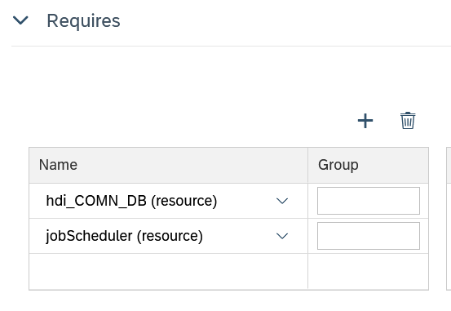

Now edit the server.js file in the node js root to add the job scheduler objects:

|  |
| --- |
| /*eslint no-console: 0, no-unused-vars: 0*/  "use strict";  var xsjs = require("@sap/xsjs");  var xsenv = require("@sap/xsenv");  var port = process.env.PORT || 3000;  var options = {  anonymous : true, // remove to authenticate calls  auditLog : { logToConsole: true }, // change to auditlog service for productive scenarios  redirectUrl : "/index.xsjs"  };  // configure HANA  try {  options = Object.assign(options, xsenv.getServices({ hana: {tag: "hana"} }));  } catch (err) {  console.log("[WARN]", err.message);  }  // configure UAA  try {  options = Object.assign(options, xsenv.getServices({ uaa: {tag: "xsuaa"} }));  } catch (err) {  console.log("[WARN]", err.message);  }  // configure job scheduler  try {  options = Object.assign(options, xsenv.getServices({ jobs: {tag: "jobscheduler"} }));  } catch (err) {  console.log("[WARN]", err.message);  }  // start server  xsjs(options).listen(port);  console.log("Server listening on port %d", port); |

Build the node js module again

Create call_event_schedule.xsjs in COMN_nodejs/lib

|  |
| --- |
| /*eslint no-console: 0, no-unused-vars: 0, quotes: 0 */  function callProc() {  var conn;  conn = $.hdb.getConnection();  var ts = new Date().toISOString();  conn.executeUpdate('call EXT.COMN_Lib_Schedule:event()');    conn.commit();  conn.close();  console.log("call_event_schedule.xsjs:callProc: ", ts);  } |

Create call_event_schedule.xsjob in COMN_nodejs/lib

|  |
| --- |
| {  "description": "Call the event schedule",  "action": "call_event_schedule.xsjs::callProc",  "schedules": [{  "description": "Perform call_event_schedule.xsjs::callProc every minutes",  "xscron": "* * * * * * 1",  "parameter": {}  }]  } |

Do the same for call_auto_revalidate.xsjs/xsjob.

Build the node.js and then start it again

Login to Job Scheduler Dashboard:

<https://jobscheduler-dashboard.1b09.calliduscloud.com/>

Search Instances 🡪 Open Dashboard

Click on entry with Name ending in “call_event_schedule.xsjob”

Schedules 🡪 Perform call_event_schedule.xsjs::callProc every minutes 🡪 Logs

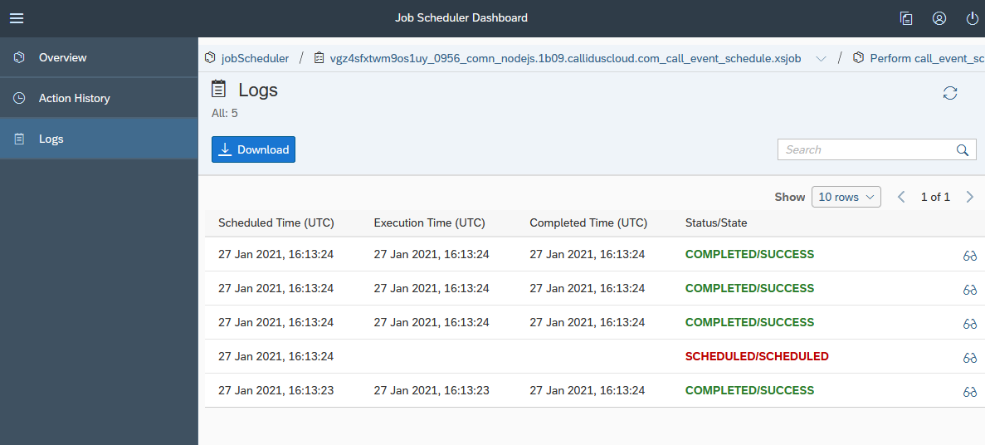

We can see the process has run successfully.

Debug table confirms that process is being called:

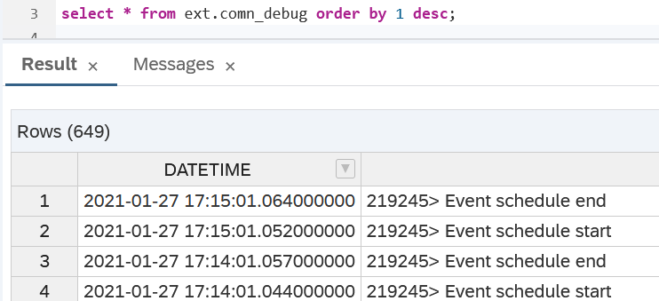

# Configuration

## Stage Hook Descriptor

Ticket: 41122 / 2021

|  |  |
| --- | --- |
| Subject | Deploy StageHookDescriptor to 0956 |
| Description | Please deploy attached StageHookDescriptor to 0956 environment. Jon Cadby is primary contact for this ticket. |

# Commissions

Import XML:

* INTS Event Role.xml
* INTS KG.xml

# Workflow

## Import Workflows

Proxy to PortalAdmin

Access Workflow

Setup

Administration --> Migration Manager

Import

Component: Workflow

Set Filename

Check radio button “Create new object or overwrite existing objects (based on system id)”

Click Import button

## Configuration

Import configuration

Proxy to PortalAdmin

Access Workflow

Setup

Administration --> Migration Manager

Import

Component: Custom Params

Set Filename

Check radio button “Create new object or overwrite existing objects (based on system id)”

Click Import button

Development 🡪 Custom Parameters

Update the settings for the database

datasource.COMN.username

datasource.COMN.password

# Smoke Test

## Reset

Remove batch

|  |
| --- |
| call ext.comn_lib_pipeline:r_f_v_batch_all('0956_GEVO_SHUK_20201208_080000_SmokeTest.txt'); |

Reset all tables

|  |
| --- |
| call ext.comn_lib_utils:reset_tables(i_bzo => true, i_vbo => true);  call ext.pl_lib:test_reset(); |

## Steps

Put file in drop box

File processed by CDL:

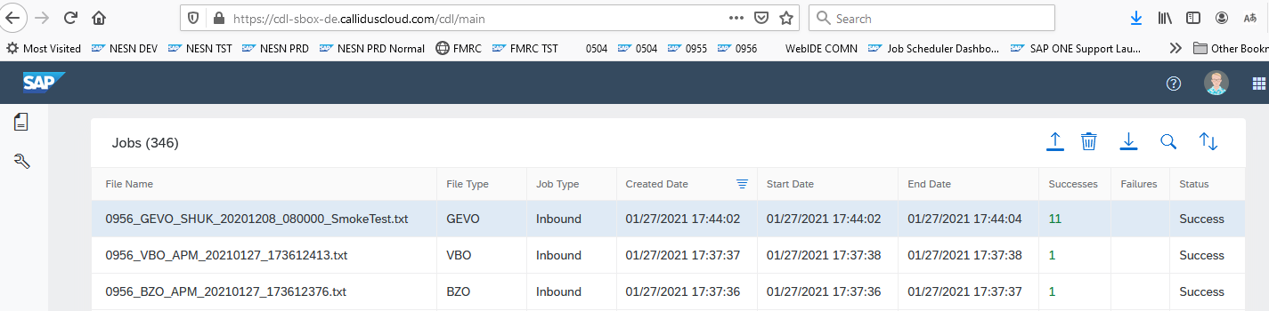

File entries:

|  |
| --- |
| select * from ext.comn_file order by file_key desc; |

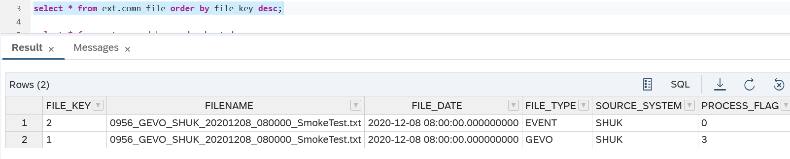

The process of EVENT waits for APM sync

|  |
| --- |
| select * from ext.comn_debug order by 1 desc; |

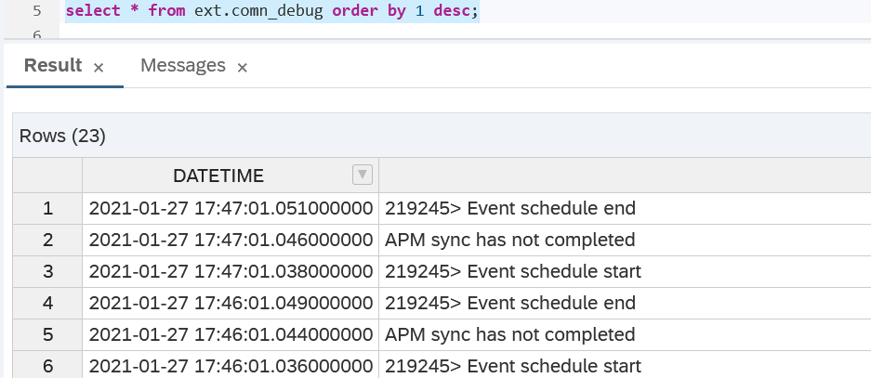

Manually generate the BZO and VBO file extract in APM

File entries:

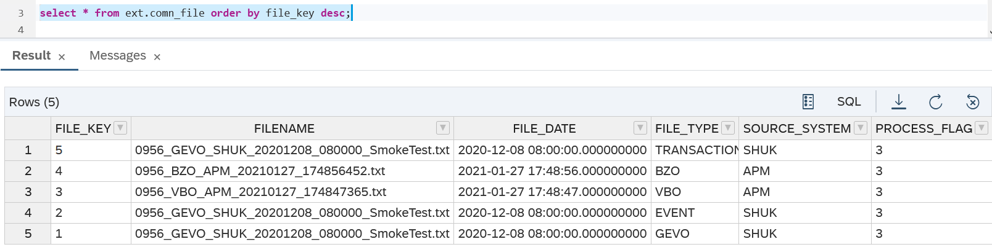

Import successful:

